**Makeup Examination November/December- 2022**

**II semester Diploma examination**

**Project Management Skills (20PM01T)**

**Scheme and answer**

**Course: Project Management Skills Course Code: 20PM01T**

|  |  |  |  |
| --- | --- | --- | --- |
| **Q. NO.** | | **QUESTION** | **MARKS** |
| **SECTION - 1** | | | |
| **1** | **a** | (i) Definition (any general definition for project)  (ii)Definition of CP | 2.5M 2.5M |
| **b** | Any five firms | 5*1=5M |
| **c** | Any five characteristics | 5*1=5M |
| **d** | Any five firms | 5*1=5M |
| **2** | **a** | Any four differences | 5*1=5M |
| **b** | Brief explanation | 5M |
| **c** | Any five features | 5*1=5M |
| **d** | Any five applications | 5*1=5M |
| **SECTION - 2** | | | |
| **3** | **a** | Any 4 points | 4*1=4M |
| **b** | Any 6 points | 6*1=6M |
| **c** | Work Breakdown Structure | 5M |
| **d** | Definition of Communication Any 3 channels of Communication | 2M 3M |
| **4** | **a** | Any 2 type Project teams  Definition of Project Advisors | 2M 2M |
| **b** | Definition  Any 4 steps of Project Direction | 2M 4M |
| **c** | Work Breakdown Structure | 5M |
| **d** | Any 5 prerequisites | 5*1=5M |
| **SECTION - 3** | | | |
| **5** | **a** | Four phases  Explain Project Initiation phase | 2M 3M |
| **b** | Explanation  Three steps in Scenario Analysis | 2M 3M |
| **c** | Explain Quality plan  Explain Communication plan | 3M 2M |
| **d** | Any five reasons | 5*1=5M |
| **6** | **a** | Definition Any six types | 2M 3M |
| **b** | Explanation on project closure phase in project management. | 5M |
| **c** | Explain Issue Management Explain Procurement Management | 3M 2M |
| **d** | Any five reasons | 5*1=5M |
| **SECTION - 4** | | | |
| **7** | **a** | (i)Definition of Project planning  (ii)Any six tools | 2M 3M |
| **b** | Explanation on Gantt chart | 5M |
| **c** | List five principles | 5*1=5M |
| **d** | Developing a network diagram | 5M |
| **8** | **a** | Any five purposes | 5*1=5M |
| **b** | (i) Explain Time estimate (02)  (ii) Explain Optimistic time (01) Explain Most likely time (01)  and Explain Pessimistic time (01) | 2M 1M 1M 1M |
| **c** | Setting Goals  Objectives | 3M 3M |
| **d** | Any four questions | 4*1=4M |
| **SECTION - 5** | | | |
| **9** | **a** | Any five uses | 5*1=5M |
| **b** | Any five differences | 5*1=5M |
| **c** | Any five functions | 5*1=5M |
| **d** | Develop Gantt Chart | 5M |
| **10** | **a** | (i) Any three purposes  (ii) Any four objectives | 3M 2M |
| **b** | Explain initial review in a project  (Explanation) | 5M |
| **c** | Any five objectives | 5*1=5M |
| **d** | Any Two Steps | 5M |

**SECTION – 1**

**1 (a) Define (i) Project (ii) Critical Path.**

**(i) Project**

A project is a temporary, unique and progressive sequence of tasks that must be completed on time to attain a certain outcome.

OR

Project is a temporary endeavor undertaken to create a unique product orservice.

OR

A project is a one-shot, time limited goal directed, major undertaking, requiring commitment of varied skills and requirements.

OR

Project is a work plan which is scientifically devised with the right man for the right work at the right time to achieve a specific objective within a certain set time frame.

OR

Project is a unique process, consist of a set of coordinated and controlledactivities with start and finish dates, undertaken to achieve an objective confirming to specific requirements, including the constraints of time cost andresource. (ISO10006).

**(ii) Critical path:**

**Critical Path** **(CP)** is defined as the longest estimated sequence of interdependent activities that should be accomplished on time to ensure completion of the project on due-date. The critical path activities are performed under the “predecessor-successor” relationship, so that any next activity cannot be started until its predecessor is complete.

**1 (b) Obstacles in project management.**

* Project complexities.
* Coordination with the many agencies
* Restructuring the organization is a typical task.
* Change in technology needs highly qualified team.
* Forward planning and pricing in a project.
* Execution of customer’s special requirement may result in time delay.
* Project risks, coupled with statutory changes are nightmare for the project manager.

**1 (c) List the five characteristics of Project Manager.**

* Flexible and adaptable to all circumstances.
* Initiativeness and should be a good leader.
* Aggressiveness, confidence, persuasiveness and verbal fluency Effective communication skills.
* Ambition and forcefulness.
* Effectiveness as integrator of project personnel.
* Poised with enthusiasm, in agitation, spontaneity.
* Able to identify problems ahead.
* Able or willing to devote most of his time for planning and controlling.
* Willing to make decisions which are acceptable to the team.
* Ability to maintain proper balance in the use of time.

**1(d) List the well-known consulting firms.**

* TATA Consultancy Services Ltd.
* Dastur and Co Ltd.
* Birla Technical Services.
* Kirloskar Consultancy Ltd.
* Power Consultancy Services India Pvt Ltd.
* Technical Consultancy Organization.
* Science and Technology Entrepreneurship Park Ltd.

**OR**

**2(a) Identify any four differences between project and operation.**

Difference between project and operation are as follows:

**Sl. #**​**Project**​**Operation**

1. Temporary.​Repetitive.

2. Unique.​Continuous cycle.

3. Create new product, service or​Product, service or process alreadyprocess.​created and are in use.

4. Performance, time and cost are​Performance, time and cost areknown. uncertain.

5. Developing a new system.​System already exists, maintaining and sustaining.

6. Unexpected inputs and outputs.​ Expected inputs and outputs.

7. More/High risk, usually done​ Fewer risks as they are repeated many for the first time.​times.

8. When objectives are achieved​ Multiple objectives to be achieved the project ends. again and again.

**2(b) *Roll of project consultants…***

* Project consultant with abundant knowledge and experience in guiding the project is an asset to every organization.
* Project consultant provide the guidance as well as direction to the project right from formulation state to the completion.
* Consultant’s services are essential for proper integration of appropriate estimate, competent contractor, effective and efficient project management to achieve their goals.
* Project consultants are also the part of project management team as paid member.
* When the project is taken up for execution, the first task is to assess the requirements of the outside consultant services or in house experts available and they should be sufficient for proper execution of the project.

**2(c) List any five features of a project.**

Following are some important features of a project:

* Unique in nature. (No two projects are exactly similar)
* Have definite goals (objectives) to achieve
* Require set of resources.
* Have a specific time frame for completion with a definite start and finish.
* Project has a life cycle reflected by start, growth, maturity and decline
* Involves risk and uncertainty
* Require cross-functional teams and interdisciplinary approach.
* Change is an inherent feature in any project throughout its life.

**2(d) Discuss any five applications of AR and VR.**

The applications of AR and VR in Project management are as follows:

i. ***Architecture, civil engineering, construction and real estate:***Instead ofstandard 2D format of drawings and renderings, investors and customers can now experience realistic impression of their futurebuildings, flats, and business places, both from the outside and from theinside.

ii. ***Marketing and sales:***Many companies have recognized additional valuesfor both marketers and customers. For instance using app helps customers in fast decision making.

iii. ***Education:***AR/VR technologies offer great opportunities and diversity in education (remote learning, interactive learning etc.)

iv. ***Visual industries:***There are many examples of using AR/VR and relatedprojects in this field; game industry, fashion industry, entertainmentindustry - cinema, film, travelling exhibitions (e.g. landmarks, museums) etc.

v. ***Automotive:***AR/VR solutions are used for test drives, car elementstesting, car dealership experience, etc.

vi. ***Manufacturing:***In complex manufacturing processes AR is useful in delivering the right information at the right moment to factory workers on assembly lines.

vii. ***Healthcare:***Training of surgeons is one of the most important fields of application of the AR/VR technologies in healthcare.

viii. ***Defence:***The project uses different approaches allowing remoteconnection of AR and VR systems to geo-location and other tools, involving 3D modeling, photogrammetric, drones and many otherstate-of-the-art technologies.

ix. ***Service support:***Remote technical and expert support, visualizedinstructions, remote repairing, knowledge, exchange, etc., with theAV/VR technologies, maintaining and repairing at remote locations is possible.

**SECTION – 2**

**3 (a) List objectives of Project Management;**

Following are the objectives of Project Management

1. The successful development and implementation of all project’s procedures[.](https://blog.planview.com/work/project-management-process/)
2. Productive guidance, efficient communication and apt supervision of the project’s team.
3. The achievement of the project’s main goal within the given constraints.
4. Optimization of the allocated necessary inputs
5. Production of a complete project which follows the client’s exclusive needs and objectives.
6. Project management aims to plan, co-ordinate and control the complex and diverse activities of the modern industrial and commercial projects.
7. The purpose of project management is to predict as many uncertainties and problems as possible and to plan, organise and control activities so that the project is completed successfully in spite of all the risks.

**3 (b) Discuss the significance/advantages of Project Design.**

1. It gives a comprehensive idea about the entire project.
2. It is a diagrammatic representation of the work plan designed to execute the project.
3. The various activities of the project are explained in sequence to highlight the various phases of the project.
4. It helps entrepreneurs in coordinating project activities.
5. It serves as an effective tool of planning and implementation of a project.
6. It helps managers to plan the project economically.

**3 (c)** Develop Work Breakdown Structure for the construction of residential house.

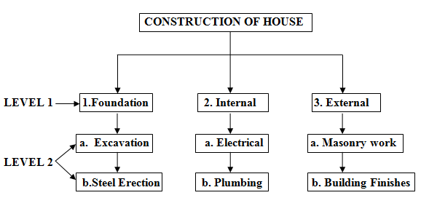

**3 (d) Describe Communication in organization and mention channels of Communication**

Communication is the exchange of facts opinions ideas and emotions between different persons.

Communication is a two-way process which involves transferring of information or messages from one person or group to another. This process goes on and includes a minimum of one sender and receiver to pass on the messages. These messages can either be any ideas, imagination, emotions, or thoughts.

**Channels of Communication** **(Any 3)**

1. Face-to-face conversations/Oral conversations
2. Videoconferencing
3. Audio conferencing
4. Emails
5. Written letters and memos
6. Chats and messaging
7. Blogs
8. Formal written documents
9. Spreadsheets.
10. Symbols
11. Public address system

**OR**

**4(a) Mention different types of Project teams and describe Project Advisors**

Different types of a project teams are :

1. Initial project team
2. Project manager
3. Core project team
4. Full project team
5. Project advisors
6. Project stakeholders
7. Process facilitators

**Project advisors:** Project advisors are the people who are not in the project team, but finally to whom the team members can depend for honest feedback and counseling. Project advisor is a person who anchors the cause of the project.

**4(b) Define Project Direction in Project Administration and list its steps**

Project Direction is the process of implementing and carrying out of those approved plans that are necessary to achieve objectives.

**Project Direction involves steps as follows.**

1. **Staffing** – Seeing that a professional person is chosen for every position.
2. **Training** – Training individuals and groups on how to fulfill their duties and responsibilities.
3. **Supervising** – Giving day-to-day instructions, guidance and discipline as required so that they can fulfill their duties and responsibilities.
4. **Delegating** – Assigning work, responsibility, and authority so that others can make maximum utilization of their abilities.
5. **Motivating** – Encouraging others to put more effort into the successful completion of the projects.
6. **Counseling** – Solve the personal problems and holding private discussions about how he might do better work.
7. **Coordinating** – Bring synchronization between different activities.

**4 (c)** Develop Work Breakdown Structure for waste water treatment Project

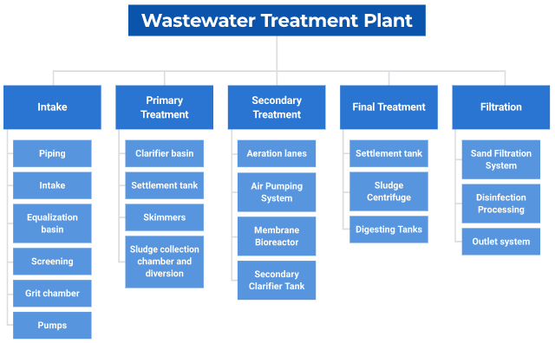

**4 (d) Describe the prerequisites for successful Project implementation**

Time and cost overruns make the project uneconomical. This also leads to shortage of resources for other projects. In order to minimize time and cost over-runs during the implementation of a project, it is necessary to study about the prerequisites for successful project implementation. Keeping checks on these prerequisites help to improve prospects of successful completion of projects. Some of the important prerequisites are

1. Adequate formulation.

2. Sound project organisation.

3. Proper implementation planning.

4. Advance action.

5. Timely availability of funds.

6. Effective monitoring.

**Section-3**

**5 (a)**  **List the four phases in Project Management Life Cycle and explain Project Initiation phase.**

**The project management life cycle has following four phases:**

1. Project Initiation
2. Project Planning
3. Project Execution
4. Project Closure

**Project Initiation phase:**

This is the first phase of the project life cycle, which in turn, has a set of activities which are to carried out before the planning phase. In this phase, the purpose and scope, justification for initiating and the solution to be implemented are defined. Also, the recruitment of skilled project team, setting up of a project office and performing an end review of this phase are done in this phase. The steps of the project initiation phase are listed below.

* Development of a business case
* Performing feasibility study
* Establishment of terms of reference/project charter
* Appointment of project team
* Setting up of a project office
* Performing phase review

**5 (b) Explain Scenario Analysis and write the procedure involved in it.**

**Scenario Analysis:**

Scenario analysis is a process of analysing future events by considering alternative possible outcomes. Scenario analysis is conducted, to analyse the impacts of possible future events on the system performance.

In sensitivity analysis, one variable is changed at a time. If variables are interrelated, as they are most likely to be, it will be helpful to look at some likely scenarios analysis, each scenario representing a consistent combination of variables.

**The procedure/ steps involved in scenario analysis are as follows:**Select the factor around which scenarios will be built. The factor chosen must be the largest source of uncertainty for the success of the project.

1. Select the factor around which scenarios will be built. The factor chosen must be the largest source of uncertainty for the success of the project.
2. The factor may be a rate of interest or state or economy or technological development or response of the market.
3. Estimate the values of each of the variables in investment analysis for each scenario.
4. Calculate the net present value and/or internal rate of return under each scenario.

**5 (c) Discuss about Quality plan and Communication plan.**

**Quality Plan:**

Quality management planning will help the project team to create a quality control plan and quality assurance plan. This step will help to set quality targets for the project to ensure that the deliverables are produced and are meeting the needs of the customer. Also, this step will help the team to schedule quality control planning and quality assurance planning activities mainly to assure the customer that the quality targets agreed, will be met. The steps of quality planning are classified into setting the quality targets and monitoring and controlling the quality.

**Communication Plan:**

The main objective of the communication plan is to communicate the right information to the right people at the right time. Further, it will ensure that the stakeholders are always provided with the right information at the right time which will pave the ways for ensuring their continued support. The steps of communication planning are divided into two types, viz, communication planning and using communication plans.

**5 (d) An International Airport project was planned with an estimated budget of 5000 crores. However, after the completion of the project, it was found that the total project cost was 5500 crores. Analyse the possible reasons for the increase in cost of the project.**

***The possible reasons for the given project cost overruns:***

1. Unplanned expansion of the project scope.
2. Inaccurate initial cost estimation.
3. Failures in project performance.
4. Errors in project design.
5. Improper risk management.
6. Improper project team building.
7. Wrong choice of equipment.
8. Incompetent material suppliers.
9. Time overrun.

**6 (a)Define the project risk and list the types of project risks.**

**Project Risk:**

Risk is defined as the possibility of an outcome being different from the expected outcome. It refers to the possibility of adverse results flowing from the uncertainty involved in carrying out the activities. The element of risk is inherent in every activity of a project. All projects are exposed to various types of risks.

**Following are the different types of risks:**

1. Technical Risks
2. Social Risks
3. Economic Risks
4. Political Risks
5. Production Risks
6. Marketing Risks
7. Financial Risks
8. Human Risks

**6 (b)****Summarise project closure phase in project management.**

**Project Closure:**

* Project closure is the last phase of the project life cycle.
* It formally closes the project and reports the overall achievements of the project in terms of defined performance measures to the sponsor of the project.
* The activities of the project closure include handling over the deliverables to the customer, passing the documentation to the business, cancelling the supplier contracts, releasing staff and equipment which were used in the project and informing stakeholders of the closure of the project.
* After certain period from the closure of the project, a post-implementation review is to be conducted to determine the level of success of the project. This will also help the project team to record new lessons that are learned during the course of the project.
* Major activities of the project closure phase, viz. project closure using project closure report and reviewing project completion using post-implementation review.

**6 (c) Discuss about Issue management and Procurement management.**

**Issue Management:**

In any project, time to time, there will be some issues with respect to staffing, supplier, equipment or other project issues. For the smooth execution of the such issues are to be identified at the early stages before they leave any impact on the project and should be resolved appropriate point of time which will lead to continuity in project progress and in turn, the projects be completed in conformity with the original proposal.

The actions of the issue management process are listed below.

* Identifying and recording all project issues clearly.
* Using issue forms to document project issue properly.
* Determining the impact of each issue on the project.
* Prioritizing each issue and reporting its status.
* Reviewing all issues and deciding the courses of actions
* Taking the steps needed to resolve the issues quickly

**Procurement Management:**

In project management, mostly the goods and services are purchased from the external sources. Under such situation, the procurement management process will help the project team to purchase goods and services from the external suppliers more efficiently. This process will give a complete set of guidelines to issue purchase orders, receive and approve deliveries, endorse supplier payments and manage supplier against their contracts.

The essence of procurement process is as outlined below:

* Identifying the goods and services that the project team wishes to procure Completing purchase orders and issuing them to the suppliers
* Agreeing on delivery time frames and methods
* Receiving goods and services from the suppliers
* Reviewing and accepting the items procured
* Approving suppliers' payments

**6 (d) A Smart City project was planned with estimated time duration of 24 months. However, the project took 36 months for its completion. Evaluate the possible reasons for the delay in the project.**

***The possible reasons for the given project time overruns:(05x01=05)***

1. A change in the scope of the project.
2. Ineffective project time management.
3. Delays in starting and executing some of the project activities.
4. A delay in one project, results in delays in subsequent projects. 
5. Use of outdated technology.
6. Political interference.
7. Poor administration.

**SECTION – 4**

**7 (a)**

1. **Define the project planning.**
2. **List the tools used in project planning.**

**(i).Definition of project planning:**

Project planning is foreseeing with blue print towards some predicted goals or objectives. Project plan is a skeleton which consists of bundle of activities with its future prospects. It is a guided activity. It is a plan for which resources are allocated and efforts are being made to commence the project with great amount of preplanning.

**(ii).List the tools used in project planning:**

Following tools are available for making project planning.

1. Gantt Chart
2. Network Diagrams
3. Product Design
4. Time Estimates
5. Critical Path Methods (CPM)
6. Work Breakdown Structure (WBS)
7. PERT chart

**7 (b) Explain Gantt chart used for project planning.**

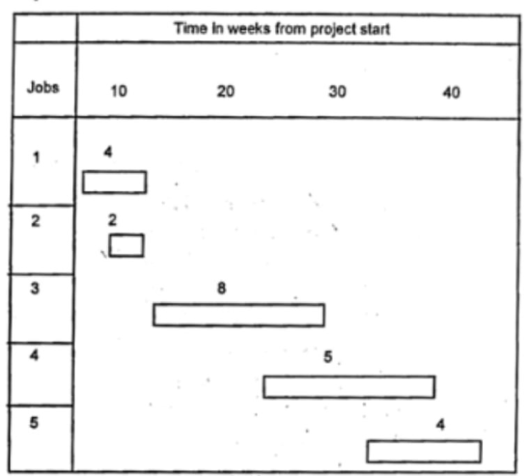 Gantt Chart is the oldest formal planning tool designed by Henry Gantt in 1993. Under this, the activities of project are broken down into a series of well-defined jobs of short duration whose cost and time can be estimated. It is a pictorial device in which the activities jobs are represented by horizontal bars in the time axis. The length of the bar indicates the estimated time for the job. The left hand end of the bar shows the beginning time, the right hand the ending time. The manpower required for the activity is shown by a number on the bar.

The project review dates are indicated by a vertical dotted line and at this time horizontal line is drawn beneath each bar to indicate the progress actually made up to the date. The length of the progress line is then drawn to represent the percentage of the job that has been completed at the review date.

**7 (c)**  **List the principles for formation of project policies.**

Project policies must be formulated on the basis of following principles:

1. It must be based upon the known principles in the operating areas.
2. It should be complementary for co-ordination
3. It should be definite, understandable and preferably in writing
4. It should be flexible and stable.
5. It should be reasonably comprehensive in scope.

**7 (d)**  **Prepare an early start schedule network diagram for the given project.**

|  |  |  |
| --- | --- | --- |
| ACTIVITY | PREDECESSOR | DURATION |
| A | --- | 6 |
| B | A | 6 |
|  |  |  |
| C | A | 11 |
| D | B, C | 16 |

**Solution:**

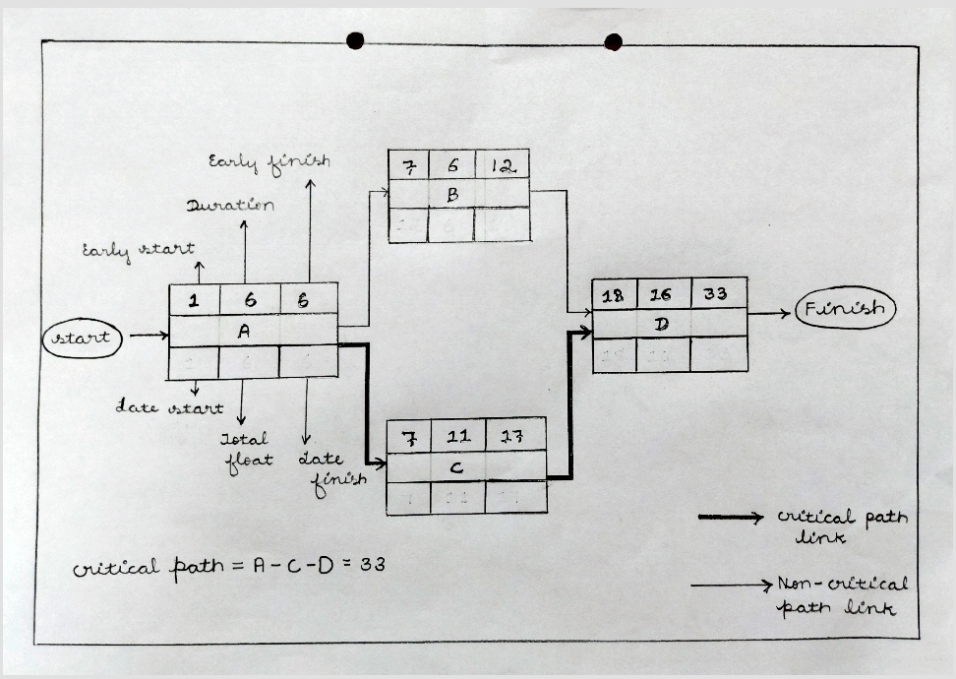

**OR**

**8 (a)** **State the purposes of project scheduling.**

**Following are the purposes of project scheduling:(05x01=05)**

1. Successively detail out the schedule to provide physical equivalence with reality.
2. Adopt the schedule to the changed realities.
3. To provide intervention when stability of the work system is being threatened and reorganize the system.
4. To obtain commitment and communicate the commitments to concerned project personnels.
5. To ensure coordination through self-regulation in first effort.
6. To link the summary of the activities appearing in the network and review the lapses.

**8 (b)**

1. **Explain Time estimate.**
2. **Distinguish Optimistic time, Most likely time and Pessimistic time.**

**(i). Time Estimate:**

* While designing a project, it is essential to fix time target for each and every activities of the project.
* It helps to complete the projects as per time schedule through which it can enjoy optimum benefits.
* Time estimate can be made by making a work break down of the project, estimating the time schedules for each work, putting them in proper sequence.
* The time estimation for completing a project depends not only on the work content/sequence but is also influenced by resources and constraints.
* The basic factors involving in the time estimation are work, constraints, resources and also the data available.

**(ii). Distinguish Optimistic time, Most likely time and Pessimistic time.**

1. **Optimistic time (to):** The optimistic time is the time required to complete the activity if no hurdles or complications arise.
2. **Most likely time (tm):** The most likely time is the time in which the activity is most likely to be completed. This estimates takes into consideration normal circumstances, making allowances for some unforeseen delays.
3. **Pessimistic time (tp):** The pessimistic time is the time required if unusual complications or unforeseen difficulties arise.

**8 (c) Discuss about setting Goals and Objectives in project management.**

**Goals:**

* Goal setting asks the question, "Where do we want to go?" (What do we want to go?).
* Before any attempts to implement a project, the planners, implementers and beneficiaries should set up goals and objectives.
* A goal is a general statement of what should be done to solve a problem.
* It defines broadly, what is expected out of a project.
* A goal emerges from the problem that needs to be addressed and signals the final destination of a project.

**Objectives:(03)**

* Objectives are finite sub-sets of a goal and should be specific and achievable. They should be **“SMART”** as follows:
* **Specific:** Clear about what, where, when, and how the situation will be changed.
* **Measurable:** Able to quantify the targets and benefits.
* **Achievable:** Able to attain the objectives.
* **Realistic:** Able to obtain the level of change reflected in the objective.
* **Time bound:** Stating the time period in which they will each be accomplished.

**8 (d) Analyse, why the project evaluation is important?**

Project evaluation is very important because its results are very helpful in providing answers to the following key questions;

1. What progress has been made?
2. Where is the desired outcome achieved? why?
3. Are there ways that project activities can be refined to achieve better outcomes?
4. Do the project results justify the project inputs?

**Section-5**

**9 (a)** **List any five uses of Network Techniques. (Any Five)**

Following are the uses of network technique to the management:

* 1. It indicates the start and finish time of each activity of the project.
  2. It helps in better scheduling, monitoring and control of project activities.
  3. It helps in better execution of the project.
  4. These techniques can serve as indicators of bottle necks and potential trouble spots which help in preventing the pitfalls and progress of the project as per plan.
  5. This will illustrate the type and extent of co-ordination required among the designers, contractors and other members of the project team.
  6. It helps in identifying the critical path.
  7. It helps in identifying the critical tasks and diversion of resources to these tasks so that they can be completed as per the schedule..
  8. It helps in resource allocation such as labour, machines etc.
  9. It helps to find whether or not advisable to crash project time and the impact of crashing on the cost of the project.
  10. Helps to find which activities are to be speeded up so as to minimise the cost of escalation due to the crashing.

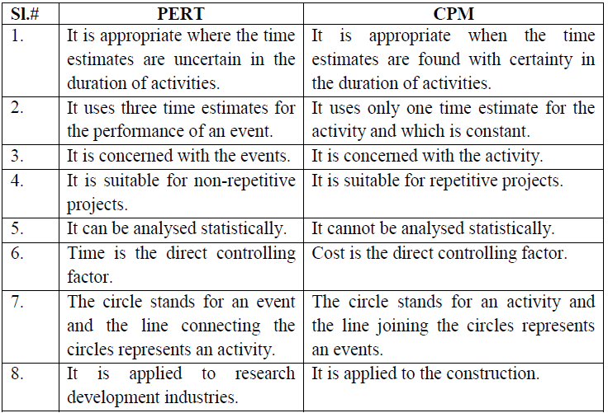**9 (b)** **Distinguish between PERT and CPM in Project Management. (Any Five)**

**9 (c)** **Analyse the functions of Project auditor. (Any Five)**

1. Providing the actual status of the project from time to time.
2. He has to examine the project methodology and techniques to achieve the project objectives.
3. Identification of factors which may create the quality problems during the project work and giving the recommendations to overcome those problems.
4. Auditor is required to give advice to make recommendations.
5. He should be competent to prepare the action plans.
6. Auditor has to evaluate the contract base lines and give his judgment on their adequacy for achieving the project objectives.
7. Auditor has to measure the present and future state of the project.
8. Timely spotting of different problems relating to the execution of the project and suggesting to overcome the above problems.
9. Establishing a good information base for a proper estimation and costing of the project.

**9 (d)** Develop a Gantt Chart for the given Project

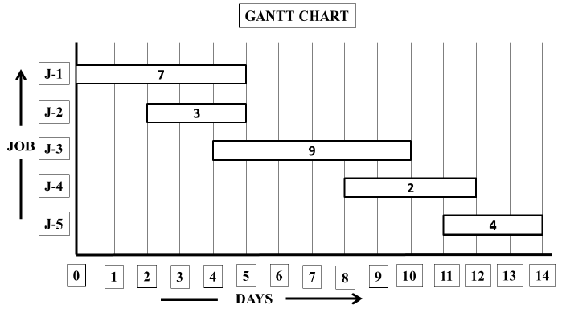

**OR**

**10 (a)** (i). List any three purposes of Project Control

(ii). List any four objectives of project review

**Purposes of project control:**

1. To control the progress of the activities.
2. To control the performance of the project activities.
3. To control the project schedule.
4. To have the control over the project cost.
5. To have control over the delays in project activities.
6. To motivate project personnel through performance evaluation.
7. To achieve the project goals effectively and efficiently

**Objectives of project review:**

1. To examine whether the project is implemented in a specified ways or not.
2. To assess the impact of the project.
3. To examine the project efficiency.
4. To measure the quality of the project.
5. To review the safety aspects followed during the project.
6. To examine the methods, process, procedures followed during the project.
7. To assess the outcome of the project..   
     
   **10 (b)** **Explain Initial review in a Project**

Initial project review is the first stage in the project review process.

It consists of two types:

**Control of Project in progress:**

* Specifies expenditure, how much can be spent by whom and when.
* It ensures that the actual expenditure does not deviate from planned one.
* It is a periodical control exercised during the project in progress.

**Post Audit:**

* It is post completion audit.
* Most of the firms do a post audit for every project above some threshold limit.
* It compares the actual performance with the planned performances.
* It assures the proper evaluation of the project and it is one-time exercise.

**10 (c) List any five objectives of Project Audit**

1. Following are the objectives of project audit:
2. Providing the clear picture of actual status of the project from time to time.
3. Creating awareness among the project staff about the type and magnitude of the problems encountering during the completion of the project and producing the quality products in a planned volume and at competitive costs.
4. Identification of factors which may create the quality problems leading to time and cost overruns.
5. Timely spotting of a variety of generic problems while executing the project and suggestions to overcome these problems.
6. Assisting to establish an appropriate standards and systems and recommending the suitable work techniques.
7. Enabling to create the good information system for a proper estimation and costing of the project.
8. Developing the experience and expertise in project management in order to provide the consultancy services to the other enterprises.
9. Identification of specific training needs with reference to the project tasks.

**10 (d) Analyse steps in Project Audit Program**

The project audit aims to obtain a clear picture of the actual status of the project from time to time. The detailed audit program involves the following steps:

**Step 1:** Preliminary examination of the project's organization, administration, record keeping, planning and control and working methods and techniques performed in order to establish project current and future status.

**Step 2:** Preparing the statements of project current and future status, giving a detailed list of completed work as compared with the project's performance baseline, recording the cost and quality aspects, record keeping, working methods and communication aspects.

**Step 3:** Conducting preliminary analysis and presenting results in the form of audit report.